Validate Change Button Fix

Problem Statement:

In current application, we have a button “Validate changes” under user story. When user clicks on validate change button, we get the user story validated. At backed, a promotion record gets created along with deployment record.

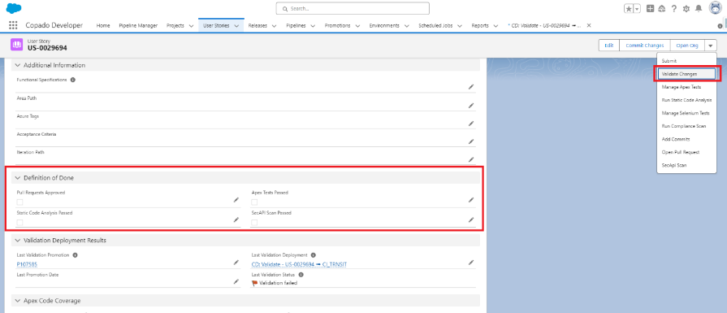

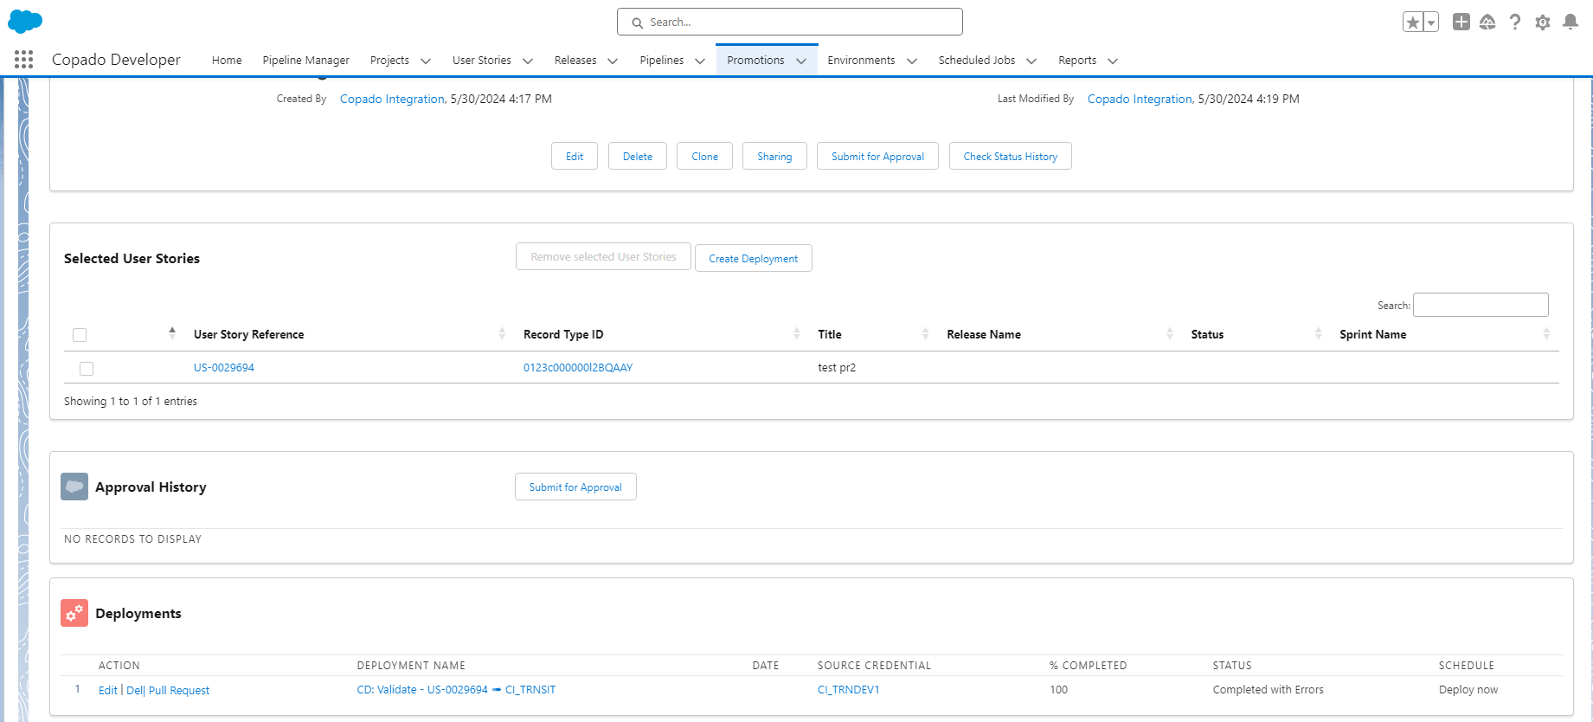

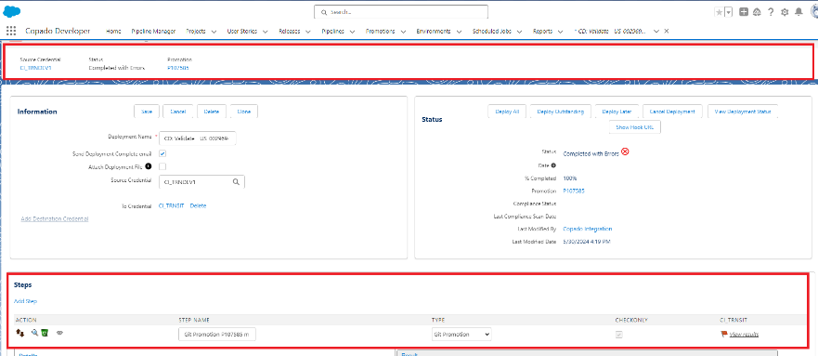

Since the Deployment record are created irrespective of DOD check, user can easily edit the deployment record steps and remove the check only and can deploy the changes. System allows the users story to get deployed to destination environment.

User can follow the same process to deploy the changes from Dev region to Prod region. In the above scenario, we are not able to stop the user to go through the Quality check.

Deployment Record Creation

There are 2 ways Deployment record gets created.

Option 1: With validation button on user story screen, deployment record gets created automatically. The process is explained in the above steps

Option 2: We can create manually on promotion record.

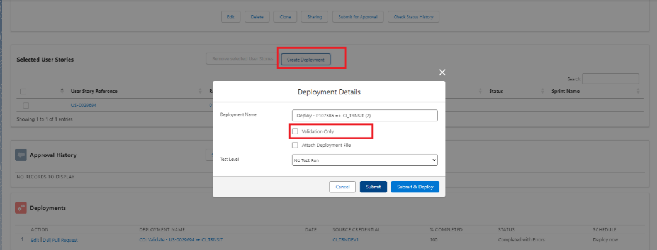

2.1 Creating deployment -With Validation check   
 Git promotion step already checked (Val)

 2.2 Creating deployment - without validation record  
 pre manual step  
 git promotion - will not have any val check unless you check  
 post deployment  
 url call out - for prod.

Solution Design

To avoid the above-mentioned problems, we need to make the following changes.

Step 1:

1. Create a checkbox (User story DOD) under step object.
2. Create a flow under step object (Before Insert)
3. step record has promotion record tagged/associated with it.
4. Start the flow when step type is git promotion.
5. Now use get record method to get all user story associated with promotion.
6. Do iteration to verify the retrieved user story DOD.
7. If DOD is true for all user story, mark the newly created check box (User story DOD) to True/checked else False/unchecked.

Step 2:

1. Create a validation rule under step object.
2. Add below logic for the validation rule.

AND(user_story_DOD= false)

1. If the above condition matches, throw error to user “Validation cannot be used as user story associated with deployment DOD/Quality check is not passed.
2. Below screenshot for reference

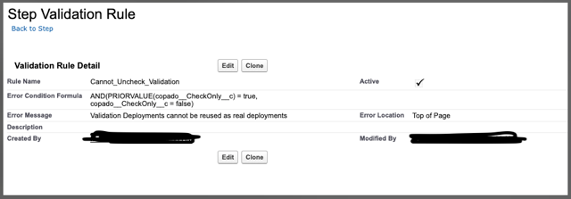

Testing Scenario

1. Create user story with DOD false/unchecked and click on validate button. Once promotion record and deployment record are created, try to uncheck the git promotion check only step.

Expected result: error message to show user that user story DOD associated with deployment is not completed.

1. Create user story with DOD true/checked and click on validate button. Once promotion record and deployment record are created, try to uncheck the git promotion check only step.

Expected result: Should allow user to uncheck the check only steps.

1. Go to normal promotion process. Create a deployment record with validation only = true from promotion. Once deployment record is created, under steps try to uncheck the git promotion check only.

Expected result: Should allow user to uncheck the check only steps.

1. Go to normal promotion process. Create a deployment record with validation only = false from promotion. Once deployment record is created, under steps try to uncheck the git promotion check only.

Expected result: Should allow user to uncheck the check only steps.

1. If user story has no Apex class or manual step, it should allow user to deploy the changes.

Expected result: Should allow user to uncheck the check only steps.

1. If hotfix should skip DOD